Learning Theory exercise 4 (Ungraded)

The subgradient is any set of vectors that satisfy

$$f\left(\vec{x}\right)≥f\left(\vec{y}\right)+ <\vec{v}, \vec{x}-\vec{y}>$$

( This definition only holds for convex functions, if it is concave instead, we would have to reverse the inequality)

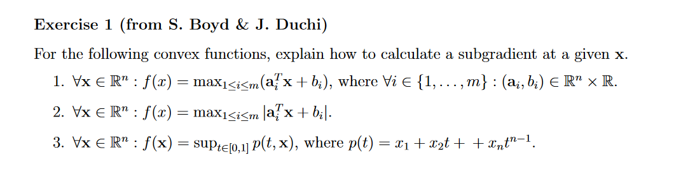

1. The function of the plane can not increase any slower than

$${\vec{a}}_{i}^{T}\vec{v}$$

We can plug in the expression into the expression and get

1. This can be completely represented by 1), simply by adding duplicate vectors with the opposite sign. Since max(a, -a) = |a|